Jade Pearl
COSC 320-001 Lab 02: Searching Algorithms 2/13/2023

Lab report: It took me approximately 2 hours to do this lab. All work is my own and I referred to past notes as well as the internet to review concepts of binary search and linear searches. I also received help from classmates to clarify the meaning of some of the lab instructions.

Pre-lab:
Reviewing the deSelSort implementation from last lab.
Reviewing design, implementation, and complexity of two searching algorithms from COSC 120 & COSC 220. I have written the Time complexity for each in their worst-case time complexity scenarios.
- Linear Search
  - Worst Case: O(n)
- Binary Search
  - Worst Case: O(log n)
Lab 01:

Exercise 1: Declare and define a function in file binSearch.h that records the total number of comparisons for an unsuccessful search

2: Write a main file lab02.cpp meeting all of the requirements from the lab instructions with variables ARRSIZE, RANDOMVALUES, RANDOMLIMIT, the array, sumFailCom, sumSucCom, and success total.

3: at the end of the main, after all searches are finished, program will output the empirical results for worst case comparisons used for both unsuccessful and successful scenarios.

Created files: binSearch.h and lab02.cpp; USED A COPY of the file deSelSort from lab01.

Source Code:
Below: lab02.cpp
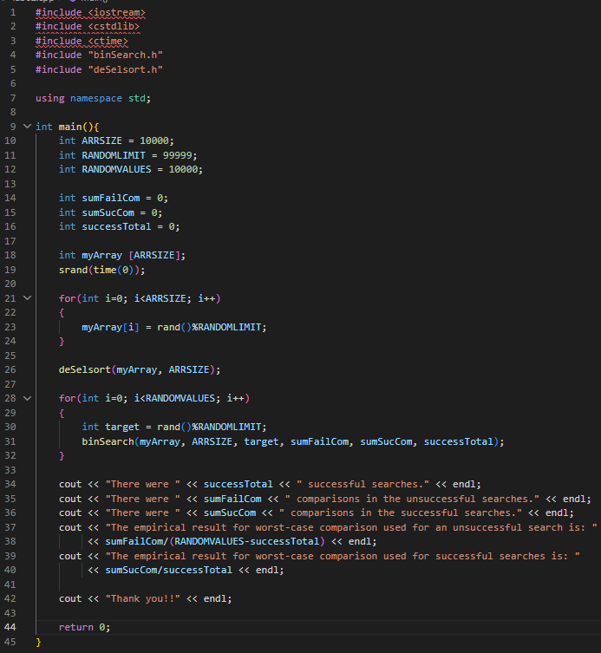
Below: binSearch.h
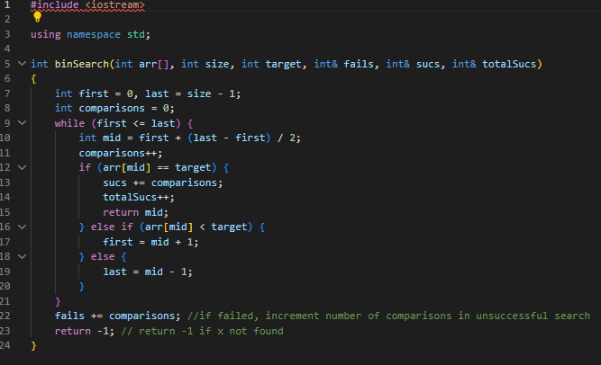

Sample Outputs:
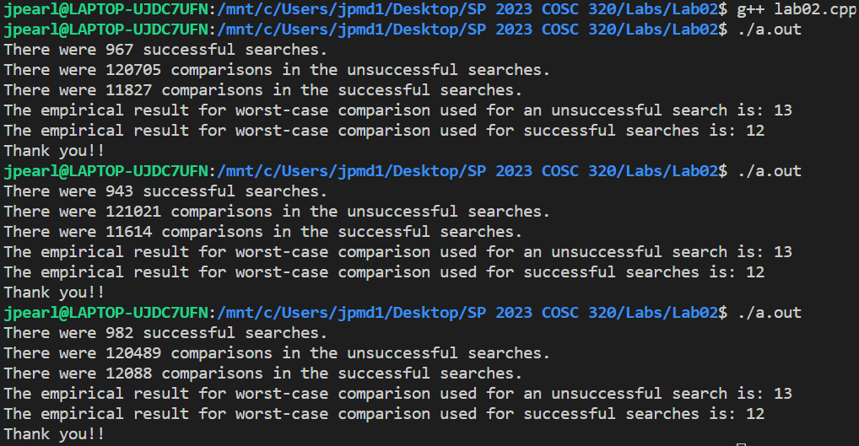

NO README file included. To compile, use linux terminal to run g++ command on lab01.cpp and then ./a.out to get the output.

Questions and Answers:
- For a random list of integers, what is the maximum number of comparisons required to find a target value by binary search?
I think the maximum number of comparisons is the number of comparisons that takes it through out the entire array before finding the target.

- Does your empirical results verify your answer for the maximum number of comparisons required to find a target value by the binary search?
Yes. However I found the answer using logic with no prediction on exactly how many comparisons would be made. The empirical results show me that the max number of comparisons for a successful search is the number of comparisons leading so a successful search divided by the total number of searches.

